PPS Maxi Cups
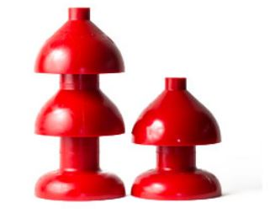

Pipeline Pigging Specialties Ltd. manufactures the aerodynamic solid cast urethane cup pig. The sleek nose maneuvers easily around short radius bends and T’s. Depending on the durometer of urethane, these pigs can manage multi-wall thickness pipe from Schedule 40 to Schedule 80.

Any SPD can also be made into a 2 cup Maxi Cup (For 10” & 12”; if alternate lengths are required).
Size | Length |  | Cup O.D. | Back Cup O.D.
 | 2 Cup | 3 Cup
3” | 4.34” | 6.954” | 3.354” | 3.40”
4” | 5-1/4” | 8.78” | 4.478” | 4-1/2”
6” | 8-1/2” | 13-1/2” | 6.40” | 6.40”
8” | 9.6” | 17” | 8-1/2” | 8.95”

