BVA & Filming

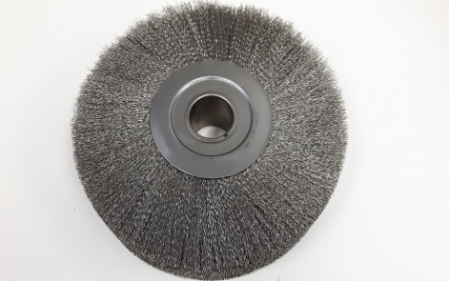

Size | Outside Diameter | Length
2” | 2.175” | 2.75”
3” | 3.40” | 4.00”
4” | 4.40” | 6.25”
5.5” | 5.50” | 6.25”
6” | 6.25” | 8.00”
6.4” | 6.4” | 8.00”
8” | 8.50” | 10.70”
10” | 10.50” | 11.00”
12” | 12.50” | 14.50”
16” | 16” | 18.50”

Wire wheel brush sizes available: 2-1/8”, 3-3/8”, 4-3/8”, 6-3/8”, 8.3125”

