BALLS & PUSHERS

Pipeline Pigging Specialties Ltd. manufactures a
wide range of Pig Balls & Pushers
Various urethane durometers, foam densities, colors,
numbers, solid cast urethane, foam core urethane,
solid foam, swab core foam
fully coated, criss cross coated, wire coated
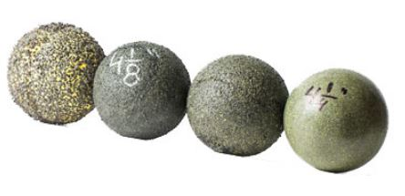
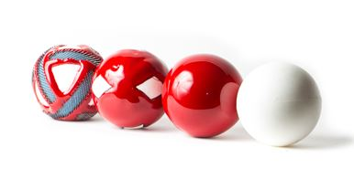
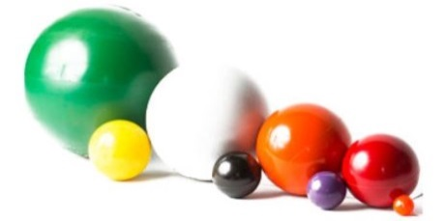
and so much more…

3/4” |  | 1” | 2” | 3” | 4” | 5” | 6” | 7” | 8” | 9” | 10” | 12” | 16”
7/8” |  | 1-1/8” | 2-1/8” | 3-1/8” | 4-1/8” | 5-1/4” | 6-1/4” | 7-1/4” | 8-1/4” | 9-1/4” | 10-1/4” | 12-1/4”
 |  | 1-1/4” | 2-1/4” | 3-1/4” | 4-1/4” | 5-1/2” | 6-1/2” | 7-1/2” | 8-1/2” | 9-1/2” | 10-1/2” |  | 24”
 |  | 1-3/8” | 2-1/2” | 3-3/8” | 4-3/8” | 5-3/4” |  |  | 8-3/4”
 |  | 1-1/2” | 2-5/8” | 3-1/2” | 4-1/2” |  |  |  |  |  |  |  | 30”
 |  | 1-5/8” | 2-3/4” | 3-3/4” | 4-3/4”
 |  | 1-3/4” | 2-7/8” | 3-7/8” | 4-7/8”

