Coatings & Applications
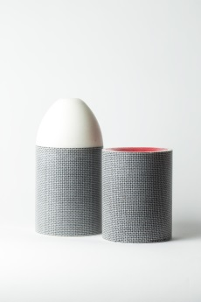
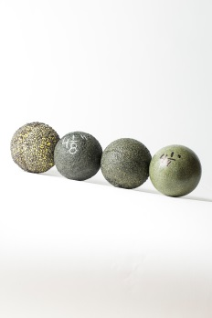
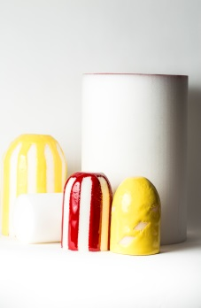
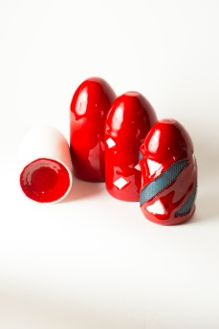
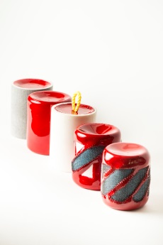

Yellow Bare Swab (YBS) | Yellow Criss Cross (YCC) & Yellow Long Coat (YLG-B)
Drying and wiping (1.61 KM) | Long distance wiping (4.83 KM)
Coated both ends for Bi-Directional | Light cleaning
Bullet nose available for multi-diameter lines | Light scraping
Handling ropes, cables or chains | Max compression
Sealing pig | Bullet nose available for multi-diameter lines
Gauging pipe I.D. | Handling ropes, cables or chains
Line proving
Pigging multi-diameter lines
Stock sizes available: ¾” O.D. up to 48-1/2” O.D. in ½” increments. Other sizes can be ordered upon request.

Red Bare Squeegee (RBS) | Red Bare Squeegee Fully Coated (RBS F/C)
Regular drying (16 KM) | Regular wiping (16 KM)
Bullet nose or bi-directional | Bullet nose or bi-directional
Handling ropes, cables or chains available | Handling ropes, cables or chains available
Bare poly foam with coating on back end for sealing | Can be made with cavity for tracking
Dewatering | Poly coating seals the entire pig
Gauging pipe I.D. | Resistant to harsh chemicals (H2S, CO2, Diesel Mix)
Line proving | Can be used for batching instead of solid cast urethane
Soft product removal in any pipe | Remains flexible with coating application for maneuvering bends
Sizes available: ½” O.D. up to 30” O.D. Bigger sizes available only in bi-directional option.

Red Criss Cross (RCC) | Red Criss Cross Wire Brush & Plastic Brush (RCCWB) & (RCCPB)
Longer distance wiping & cleaning (16 KM) | Longer distance scraping & cleaning (16 KM)
Bullet nose or bi-directional | Bullet nose or bi-directional
Handling ropes, cables or chains available | Handling ropes, cables or chains available
More wear resistance | Removal of slag, lime build-up and rust & corrosion
Removal of paraffin and/or condensate | Removal of paraffin, scale & hardened build-up
Thick and/or soft internal deposits | Best used for scraping steel pipe
More abrasive in plastic pipe | Plastic wire brush is also available-no scaring or damage to pipe walls & reduced static during pigging
Sizes available: ½” O.D. up to 30” O.D. Bigger sizes available only in bi-directional option.

Red Bare Squeegee with Mesh (RBS ME) | RBS with Ceramic Bead or Silicon Carbide (Sil C) Grit
Plastic mesh molded into foam for strength | Used for applications where internal deposits are hardened from heat
Extra-long mileage compared to RBS (25 KM) | Sil C is very abrasive – consult is recommended
Used for PVC, fiberglass, poly, epoxy-lined pipe & steel pipe | Ceramic Bead makes for a very hard coating, but has a smooth finish mainly for polishing
Both coatings are recommended for heavier densities such as 8lb., 10lb. & harder
Sil C and Ceramic Bead and all other coating applications can be applied to balls (excluding mesh), RBS, SBD, Double Dish, foam pushers and more.
Other additives can be introduced for strength & speed; please consult within.
Sizes available: ½” O.D. up to 30” O.D. Bigger sizes available only in bi-directional option.

