MAXI DISC PIGS

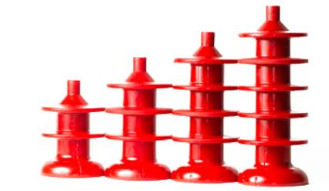

SIZE | DISC  O.D. | BACK  CUP O.D. | 3 DISC  LENGTH | 4 DISC  LENGTH | 5 DISC LENGTH | 6 DISC  LENGTH
2” | 2.175” | 2.25” | 3.25” | 4.375” | N/A | N/A
3” | 3.215” | 3.40” | 5.00” | 6.00” | 7.00” | N/A
3-3/8” | 3.39” | 3.55” | N/A | N/A | 7.5” | N/A
3-3/4” | 3.8” | 3.812” | 5.1” | 6.4” | 7.7” | N/A
4” | 4.25” | 4.30” | 6.50” | 8.12” | 9.625” | N/A
5.5” | 5.50” | 5.50” | 7.50” | N/A | N/A | N/A
6” | 6.25” | 6.50” | 8.75” | 10.50” | 12.50” | 14.00”
6.4” | 6.4” | 6.4” | 8.75” | 10.50” | 12.50” | 14.00”
6-1/2” | 6.50” | 6.50” | 9.25 | N/A | 14.25” | N/A
8” | 8.50” | 8.80” | 11.50” | 14.00” | 16.50” | N/A
10” | 10.50” | 11.00” | 14.25” | 16.75 | 19.25” | N/A
12” | 12.50” | 13.00” | 15.50” | 19.00” | 25.50” | N/A
16” | 15.90” | 16.20” | 18.50” | 23.00” | 27.00” | N/A

All Maxi Discs are available with Hollow or Solid cores and can be made in a wide range of Durometers.

