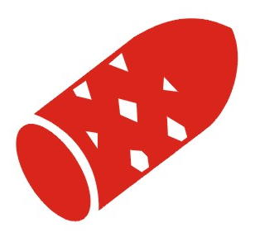
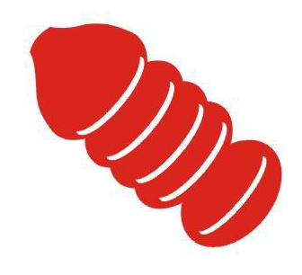

Pipeline Pigging Specialties Ltd.

603 – 21 Ave. PH: (780) 955-7776

NISKU, AB. T9E 7X9 FAX: (780) 955-2527
E-Mail: info@pipelinepigging.ca www.pipelinepigging.ca

OPEN CELL POLYURETHANE FOAM

- Light Density (2.5lb/ft³)
  - Medium Density (3-5lb/ft³)
    - Hard Density (8-10 lb/ft³)

93A Durometer Polyurethane Coating
(Colored to Specific Densities)
Sizes Available = 0.3” to 48” O.D.
Available in Sphere Design = .075” to 12.25”
Hand Launchable & Compressible

RBS (RED BARE SQUEEGEE)

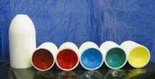
- Regular wiping and dewatering of pipelines
- Line proving
- Gauging pig to determine pipeline I.D.
- Removal of thick, soft internal deposits
- Condensate and liquid removal from wet gas systems
- Product removal
- Pigging multi-diameter pipelines
- Used as sealing pig
- Available in double dish (bi-directional) applications
- Handling ropes optional
- Transmitter cavities available for electronic tracking equipment

RCC (RED CRISS-CROSS) Most Common in 5lb. Density

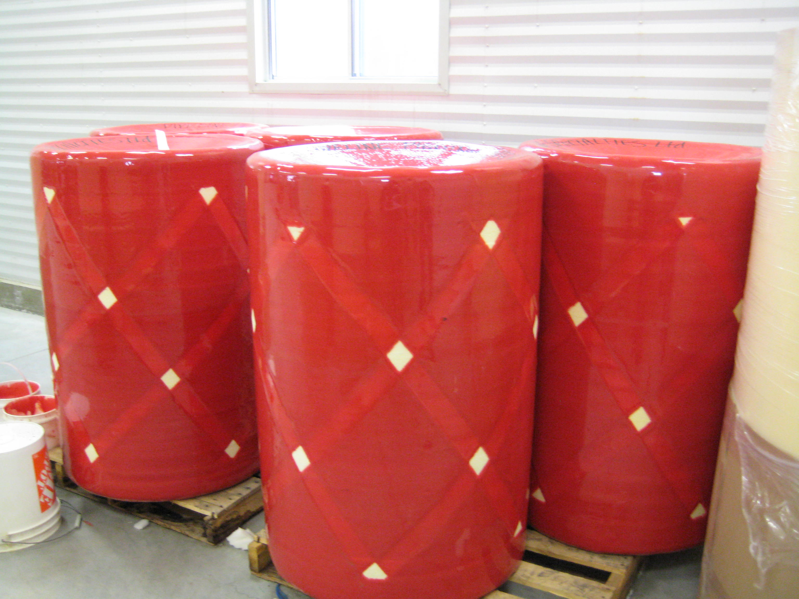
- Regular wiping and dewatering of pipelines
- Hydro-testing, Air-testing & mud plugging
- Removal of thick, soft internal deposits
- Condensate and liquid removal from wet gas lines
- Paraffin removal from crude oil pipelines
- Non-abrasive scraping
- Urethane coating enhances cleaning and wear resistance
- Used when there is danger of damaging the interior of the pipe
- Available in double dish (bi-directional) & Bullet Nose
- Handling ropes available
- Transmitter cavities for electronic tracking equipment
- Long wear resistant up to 100 kilometers

RCCWB (Red Criss-Cross Wire Brush) Most Common in 5lb. Density
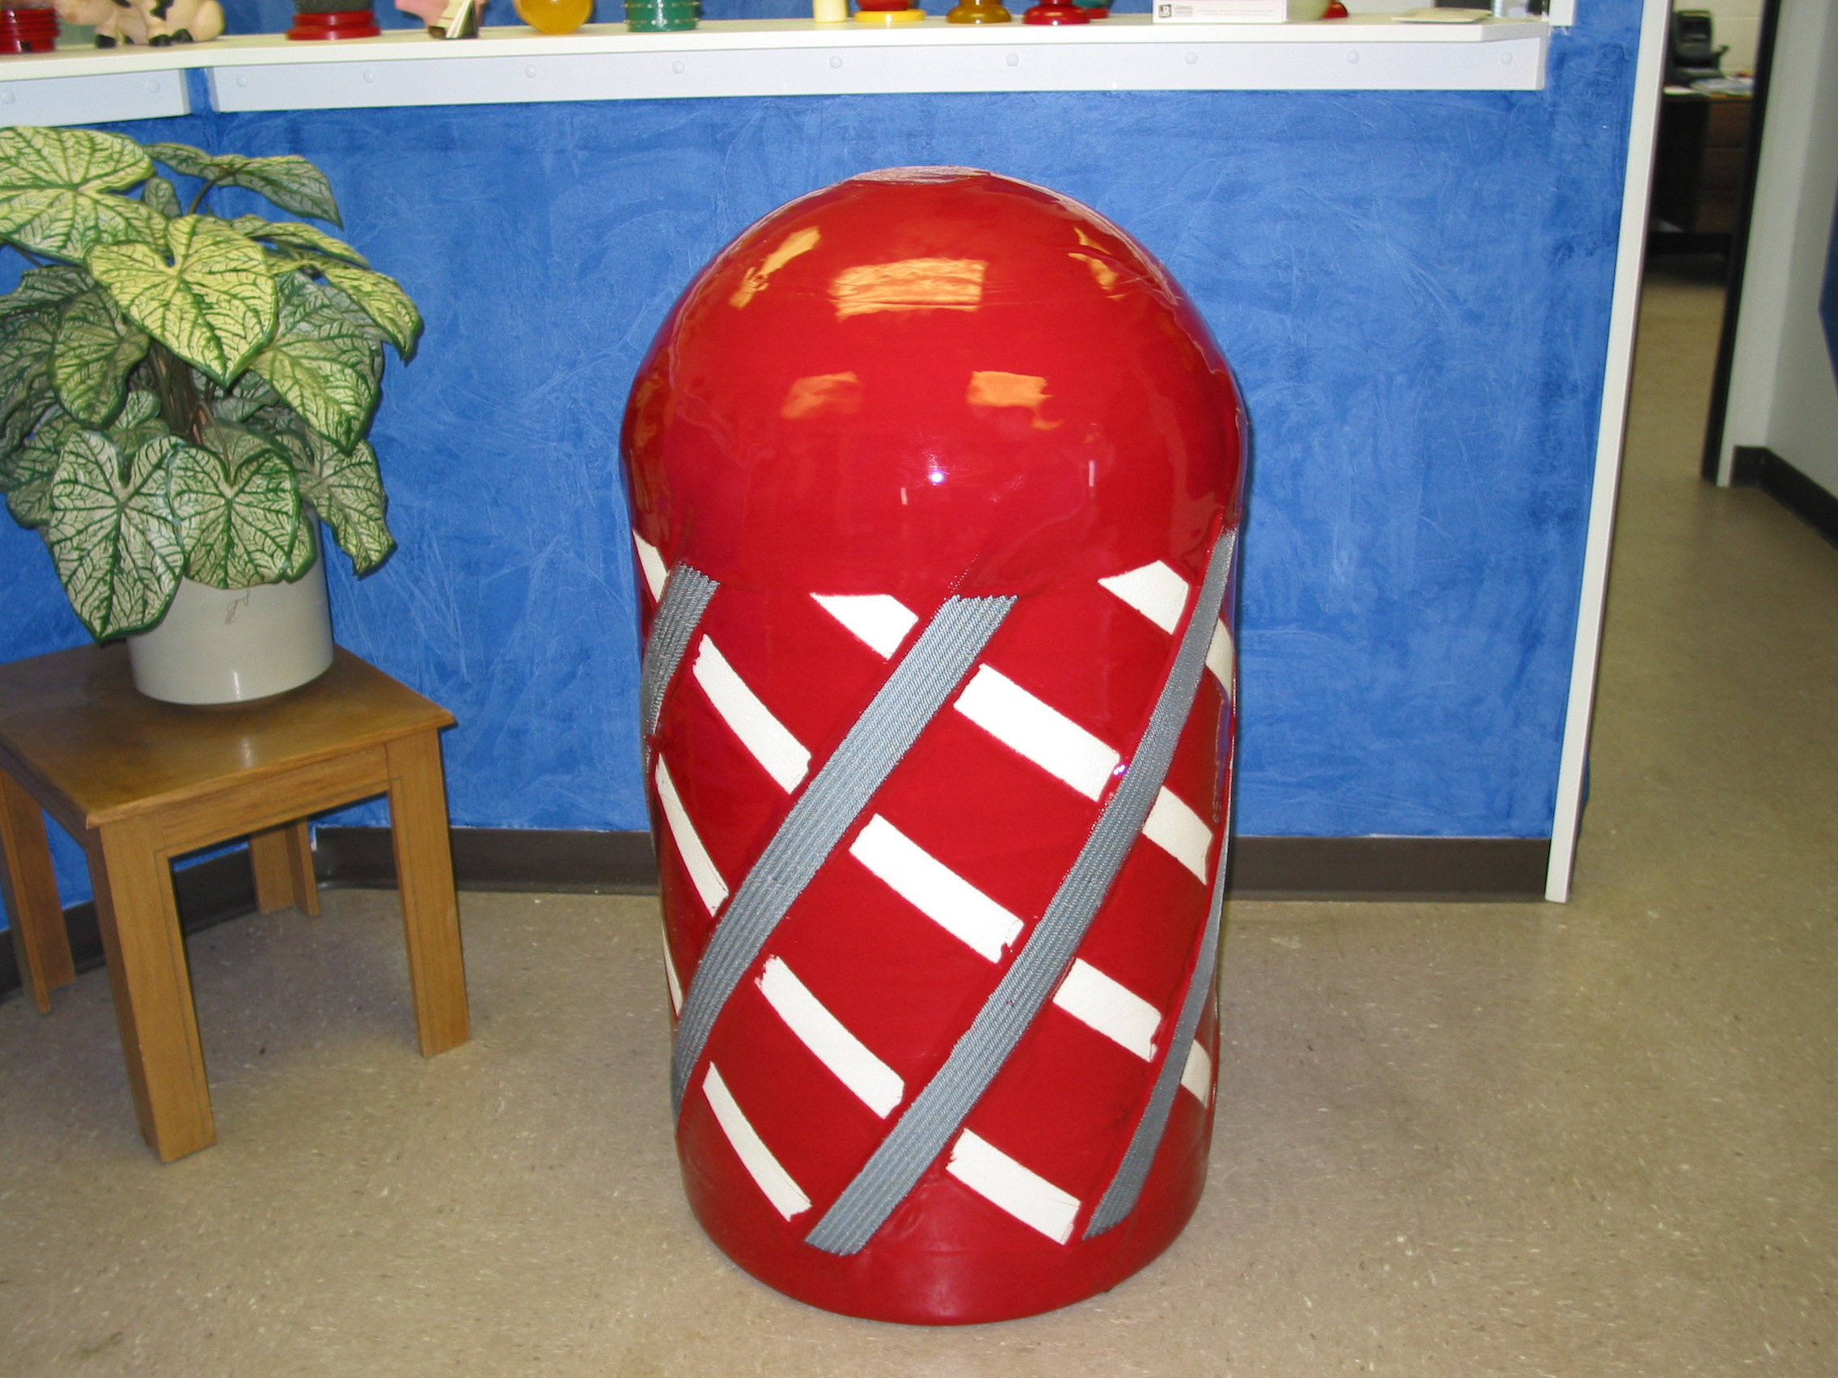
- Regular scraping of pipelines
- Recommended for most corroding pipelines
- Removal of welding debris or other foreign materials after new construction
- Used to remove hard scale, paraffin’s and heavy material
- Available in a turning pattern for more aggressive cleaning
- Available in double dish (bi-directional) applications
- Handling rope or cables optional
- Transmitter cavities for electronic tracking equipment optional

